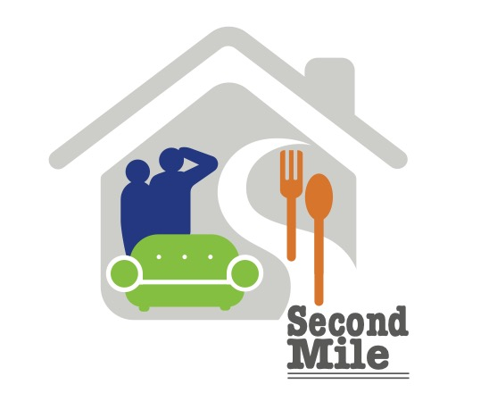
SECOND MILE OUTREACH
Individual Sponsor
Second Mile Outreach (SMO) is a 501(c)(3) nonprofit organization that provides critical food assistance, clothing, household goods and furniture for people in crisis and veterans in transition, throughout the Cleveland area. Funding for SMO’s operational expenses is enabled by partners like you. Individual Sponsor donations are 100% tax deductible to the extent allowed by law. Sponsors will also receive information on store sales, special events as well as an invitation to the Annual Meeting.

Please complete the Supporter information below, or, on-line at: secondmileoutreach.org.

Name

Phone Email

Address

Sponsorship Level and examples of what your donation can provide:
_____ $1000 Furnishes four family homes.
_____ $250 Furnishes one family’s home.
_____ $100 Provides a week’s worth of food for 10 families.
_____ $50 Supplies five veteran’s home care kits.
_____ Other

You may mail this completed form, along with your check payable to Second Mile Outreach, to the address below. If you choose to use the on-line Sponsor option, please use “Donate” button and include “Sponsor” in the notes.

Second Mile Outreach
1480 W. Bagley Road
Berea, Ohio 44017
For more information visit: secondmileoutreach.org
Phone: 440.239.0549
Contact: secondmileoutreachboard@gmail.com

