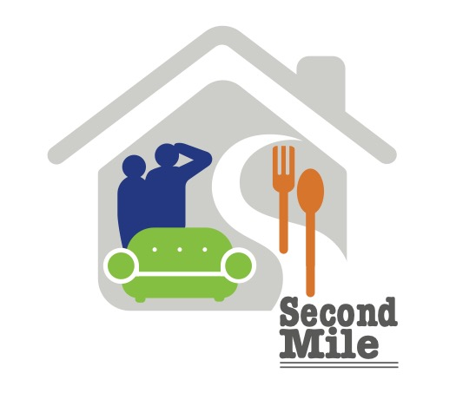
SECOND MILE OUTREACH
Organization Sponsorship
Second Mile Outreach (SMO) is a 501(c)(3) nonprofit organization that provides critical food assistance, clothing, household goods and furniture for people in crisis and veterans in transition, throughout the Cleveland area. Funding for SMO’s operational expenses is enabled by partners like you. Organizational Sponsorships are 100% tax deductible to the extent allowed by law. Sponsors will also receive information on store sales, special events as well as an invitation to the Annual Meeting.

Please complete the Sponsorship information below, or on-line: secondmileoutreach.org.

Name of organization Contact person

Email Phone

Address

Sponsorship Level and examples of what your donation can provide:
_____ $2500 Supports our food pantry for a month.
_____ $1000 Furnishes four family homes.
_____ $500 Provides a week’s worth of food for 50 families.
_____ $100 Supplies ten veteran’s home care kits.
_____ Other

You may mail this completed form, along with your check payable to Second Mile Outreach, to the address below. If you choose to use the on-line Sponsorship option, please use “Donate” button and include “Organization Sponsor” in the notes.

Second Mile Outreach
1480 W. Bagley Road
Berea, Ohio 44017
For more information visit: secondmileoutreach.org
Phone: 440.239.0549
Contact: secondmileoutreachboard@gmail.com

